THE HACKER AND MACK SHOW

**REAL FUNNY**REAL TOPICS**REAL LIFE**

**The Nations New Favorite Radio Show**

**“The Hacker and Mack Show”**

The Hacker and Mack Show is your go-to show for entertainment and pop culture gossip. Hacker and Mack have been working in the broadcast industry for over 40 years combined. And now along with Producer Rudy, their show has attracted a loyal audience with its unpredictability, unorthodox and unusual style while remaining very real and honest with the audience.“Hacker and Mack” are available for any daypart and format. Email [tommythehacker01@gmail.com](mailto:tommythehacker01@gmail.com)

****“Hacker & Mack” is currently heard on several stations across the country.**

* ***Jamn 94.7 KLBU Santa Fe, NM***
* ***I92 FM WXIW Knoxville, TN***
* ***Play FM 105.7 WERF Gainesville, FL***
* ***Splash FM 98.5 WSCK Atlantic City, NJ***
* ***WTUC 98.5 Toccoa, GA***
* ***Rhythm 105.9 KYRC Yuba City, CA***
* ***Jamz 99.9 KLZY Salinas, KS***
* ***Energy 90.5 WCGD Edgar, NS***
* ***New Country USA (Online)***

***KRYC-LP Yuba City CA and KLZY-LP Salina KS Program Director Dan Mathews adds, “The Hacker & Mack Show has had a huge impact on our station, they are super funny and relatable to our audience!”***

***Jamn 94.7 KLBU Program Director Kidd Corona raves “Tommy and Nancy are dynamic and very entertaining. The show is fun, engaging and refreshing. The Hacker and Mack show has been able to connect perfectly with our target audience of women ages 25-54”.***

**Social Media**

**@The_Hackerandmack_show**

**27 followers / 529 weekly views**

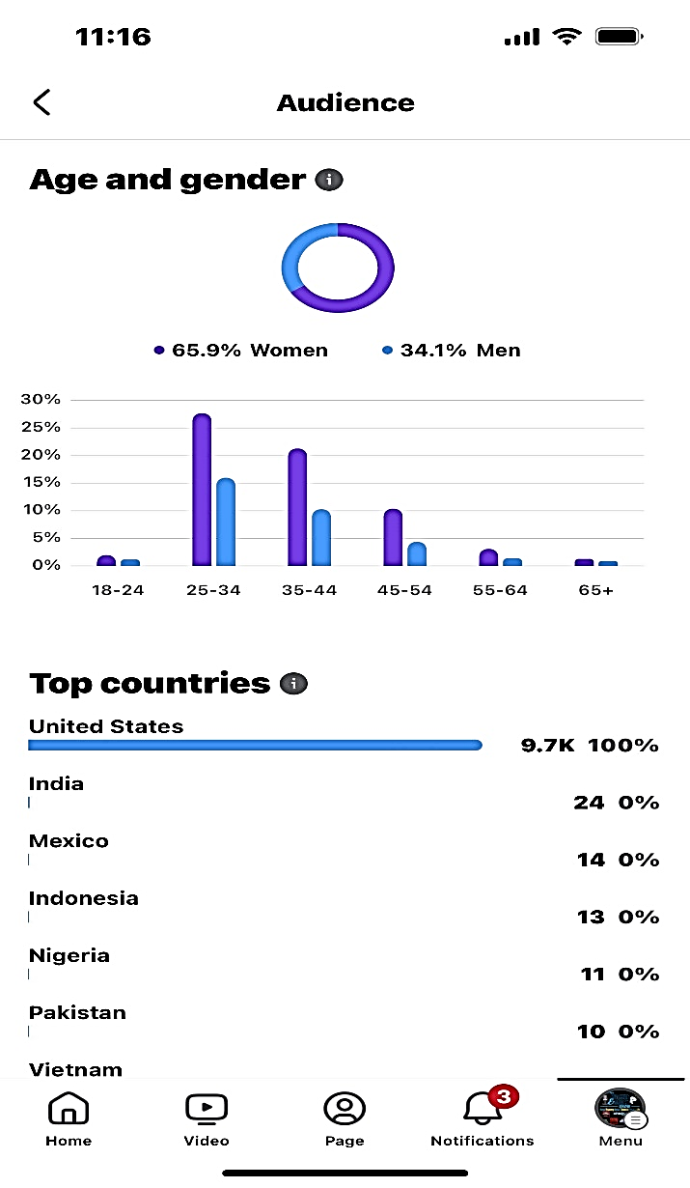**@MorningswithHackerandMack**

**9.7k followers /Target Audience W25-54**

**@TheHackerandMackShow**

**600 Weekly Views**

**@HackerandMack**

**89 followers / 926 weekly Views**

### **THE TEAM**

### **Tommy the Hacker** Born in Hollywood, California, but grew up in Denver, worked his way up by having the #1-night show in multiple markets. Tommy previously served as PD/morning host at KXSS and KQFX Amarillo, KIXY San Angelo, and has hosted mornings at KLHB Corpus Christi.

### **Nancy Mack** is a seasoned broadcaster with two decades of experience. Mack previously co-hosted mornings at Alpha Media Country 97.9 KGNC Amarillo and tracks middays on Tejano “**Q99.5**” KQCT San Angelo TX. She has previously worked in Seattle, Dallas, and multiple markets in Canada.

### **Producer Rudy** Rodolfo Hinojosa Jr. is a dynamic broadcaster with a passion for communication and entertainment. He has honed his craft at Del Mar College and gained experience at 106.5 Band Tango and Party Place Cabaret, showcasing his musical prowess and versatility. His 11 years in the Navy have taught him discipline and resilience, making him a respected figure in the industry.

|  |
| --- |
|  |